WRO Future Engineer (2024) Documentation

**YBR-AGO**

**CONTENT**

Team Picture

**Formal**

**Funny**

Team Members

Vichaiwat Koonsap

Chaiwat Chinsupawat

Vorawet Narkglom

About Team

Our team, YBR-AGO, hails from Yothinburana School. We are a group of students passionate about robotics, which led us to join the school's Robotics Club. Over the years, we've participated in several competitions. Our team comprises three members: Vorawet, Vichaiwat, and Chaiwat. This year marks our second participation in the Future Engineer competition.

Last year, Vichaiwat and Vorawet were in a team named YBR-GPA4.0, which secured first place in the Thailand round, while my team, YBR-BOO, came in second. This year, we have joined forces to form YBR-AGO. We are leveraging the experience we gained from last year's international rounds to enhance our robot for this year's competition.

## Robot aim and objective

### Objectives:

1. **Innovation and Creativity**:
   * Encourage participants to design and build innovative robots that can perform complex tasks.
   * Promote creative thinking and the development of unique solutions to the given challenges.
2. **Engineering Skills**:
   * Enhance participants' engineering skills through the design, construction, and programming of advanced robots.
   * Foster an understanding of mechanical design, electronics, and software integration in robotics.
3. **Problem-Solving**:
   * Challenge participants to solve real-world problems using robotics, requiring analytical thinking and strategic planning.
   * Develop participants' ability to troubleshoot and optimize their robotic systems.
4. **Collaboration and Teamwork**:
   * Promote collaboration and effective teamwork among participants.
   * Encourage communication and cooperation within teams to achieve common goals.
5. **Application of STEM Knowledge**:
   * Apply theoretical STEM knowledge to practical scenarios, reinforcing learning through hands-on experience.
   * Integrate multiple STEM disciplines to develop comprehensive robotic solutions.
6. **Presentation and Documentation**:
   * Develop participants' skills in presenting their projects and solutions effectively.
   * Emphasize the importance of thorough documentation, including the design process, programming, and testing.’

Robot Picture

Robot 3D model

**Robot Design.**

The Robot

Designing a robot for this competition is sometime hard. We need to design it to be compact, lightweight, durable, and have all the functions we need. The robot must be four-wheeled with a steering function on either front or back wheel, which is why we need to be careful to pick the components. After we select all the components we need, then we think about how to put them all together. We came up with two choices. The first is with Lego Technic parts, but due to its size and weigh,which must be 300x200mm and 300mm in height, that makes it hard to design a compact robot. So we decided to use a 3D-printed robot for more lightweight, and we can also put the component anywhere we want with just designing.

3D printing is also not easy since we need to be precise; every hole and component size must fit into places we want. We failed a few times before coming up with the design we use now. After finishing designing, we printed it out to see the result with our own 3D printer and using ABS filaments. The robot color also shouldn't be green and red since the camera can be confused with the obstracle.

For the design, we placed the gyro around the middle-top of the robot to get the most accurate output, while the camera was positioned at the front of the gyro to detect objects quickly.

Our robot has two servos, one on the bottom front and one on the top front. The bottom front servo is used to steer the wheel. Then, we added a top servo that rotates our ultrasonic. We use an ultrasonic to keep our robot out of the wall. Finally, we place our motor at the bottom back of the robot, and to ensure that it drives both wheels at the back, we use a gear differential from Lego.

**3D Printer**

1.Bambu Lab X1-Carbon 3D Printer

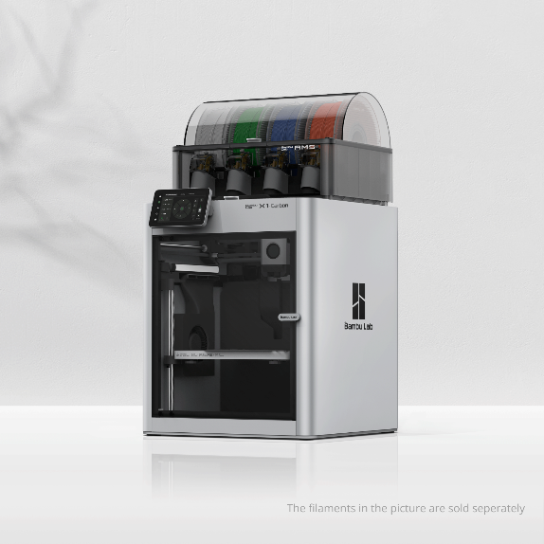

The reasons that we use Bambu Lab X1-Carbon 3D printer because this printer is a high-performance 3D printer designed for precision and efficiency. It is equipped with advanced technology and features, making it suitable for professional use as well as hobbyist projects that require high-quality prints.

### Key Features:

1. **Robust and Durable Structure**:
   * The printer is made from carbon material, ensuring high strength and long-lasting durability.
2. **High-Speed Printing**:
   * Supports high-speed printing without compromising on the detail and quality of the prints.
3. **Versatile Material Compatibility**:
   * Can print with a variety of materials such as PLA, ABS, PETG, TPU, and more, allowing for diverse project applications.
4. **Accurate Temperature Control**:
   * Features precise temperature control systems to ensure consistent and high-quality prints.
5. **Automatic Bed Leveling**:
   * Includes an automatic bed leveling system to ensure the print platform is correctly leveled for optimal printing results.
6. **Touchscreen Interface**:
   * Comes with an easy-to-use touchscreen interface, making it simple to adjust settings.
7. **Multiple Connectivity Options**:
   * Supports USB, Wi-Fi, and SD card connectivity for seamless data transfer.
8. **Problem Detection and Alerts**:
   * Equipped with systems to detect printing issues and alert the user, allowing for immediate problem resolution.

### Specifications:

* **Print Volume**: Approximately 256 x 256 x 256 mm
* **Print Resolution**: 50-300 microns
* **Print Speed**: Up to 500 mm/s
* **Nozzle Size**: 0.4 mm (other sizes supported)
* **Supported Software**: Bambu Studio, Cura, Simplify3D, PrusaSlicer

### Applications:

* Ideal for creating complex and precise parts.
* Suitable for prototyping, educational projects, design work, and artistic creations.

### Maintenance:

* Regular cleaning of the nozzle and print platform is recommended.
* Regular software updates ensure optimal performance.

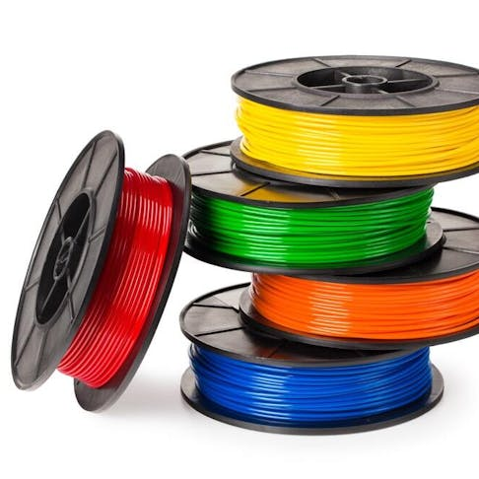**Filament**

ABS (acrylonitrile butadiene styrene) is probably the most common filament used in 3D printing. It is especially valuable in strong plastic parts that must remain resilient in the face of temperature swings. It is mainly used in FDM (fused deposition modeling) 3D printers. ABS is a thermoplastic polymer composed of three monomers: acrylonitrile, butadiene, and styrene. The material was first patented in the 1940s and very quickly gained popularity.

ABS is used in many industries today because of its flexibility, moldability, and strength. You can find it in such varied products as Lego toys, home appliances, and piping systems. Compared to most inexpensive polymers, ABS is quite flexible, resists high temperatures, and can easily be machined. In the realm of 3D printing, it is valued because it prints quickly and is more durable than many other options. This article will define ABS 3D printing filament, examine its composition and properties, and compare it to other 3D printing filaments.

**Engineering information**

**1.Motion control**

LEGO Power Functions L-Motor

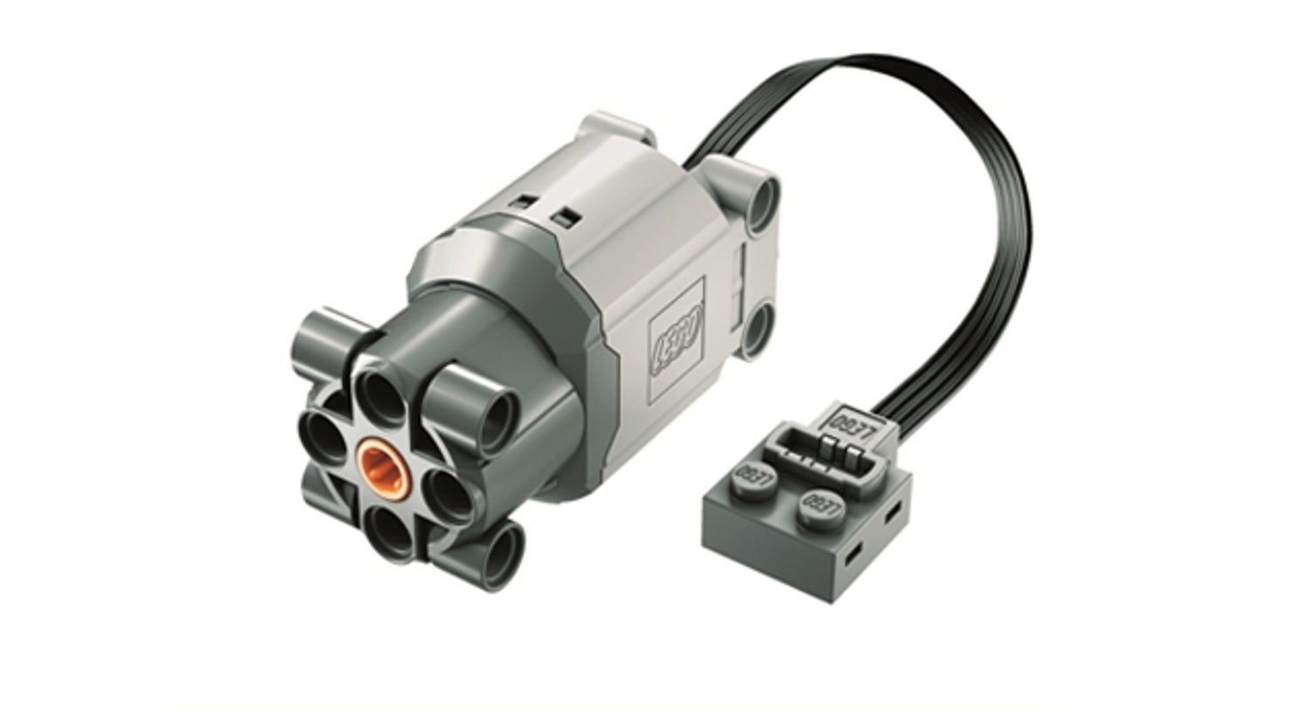

It's a simple motor, and we chose this motor because of its easy connection to our robot and its cost-effectiveness. This motor is small yet powerful. and it is the perfect size for our robot. The motor comes with a dedicated port for Lego. So, we modified it to make it able to connect to the board. We use Lego’s Differential gear with an inner tap and some Lego axle to create a chassis. The axle attached to the differential gear is separated into two sides so the wheel on each side can move independently and enable the steering mechanic to work smoothly. Then we surround it with the Lego parts to create the main frame.

**3D Model driving part:**

**Technical information:**

Weight:

maximum speed and

electric current volume

speed compare to volt

|  |
| --- |
| **Specification:** |
| Category LEGO Parts |
| Subcategory Electrical |
| Theme LEGO Power Functions |
| Brand LEGO |
| Primarily suited for Boy/Girl |
| Color Light Bluish Gray |
| Released in 2012 |
| Age advice From 6 years |
| Weight 45 grams |
| Dimensions (LxWxH) 7 x 4 x 3 studs |

Geekservo 360 Degrees

We use Geekservo 2kg 360 Degrees for steering the robot and employ an Ultrasonic Sensor for rotation. This servo is compatible with LEGO, making it easy and convenient to build the robot. We like how you can connect two axles to the dual outputs on this servo so you can power two wheels or gears, or mount the servo securely inside articulated limbs and other contraptions. It's also easy to connect blocks to the sides by poking the studs into the holes.

The gears inside these servos will 'slip' when the blocking load is too high instead of jamming - helping avoid damage to your servos and boards.

The wires are a standard servo pinout -

* Red - positive
* Brown - negative
* Yellow - data

The cable has a fused 1x3 female DuPont socket connector on the end, so it's easy to connect to [jumper jerky](https://shop.pimoroni.com/products/jumper-jerky) or 0.1" pitch pin headers.

**Specifications:**

Temperature Range: -20 ℃ to 60 ℃

Operating Temperature: -10 ℃ to 50 ℃

Electrical Voltage: 4.8V ~ 6V (Servo) / 3V (Motor)

**Description**

* Geekservo 2kg 360 Degrees
* Offers 360-degree dual output axles
* Suitable for middle or large projects
* Compatible with Lego
* Working Voltage: 3.3 - 6 V
* Operating Speed (no load): 0.14sec / 60° (4.8V)

The Geekservo 2kg 360 Degrees Compatible Lego offers 360° dual output axles and is compatible with Lego. It is suitable for middle or large projects and operates on a working voltage range between 3.3 - 6 V voltage.

**Flowchart:**

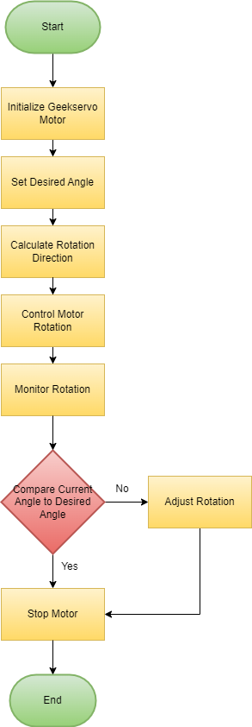

**2. Energy management and inspection**

**Ultrasonic Sensor** (Gravity: URM09 Ultrasonic Distance)

An Ultrasonic [sensor](https://www.dfrobot.com/category-36.html) is a device that can measure the distance to an object by using sound waves. It measures distance by sending out a sound wave at a specific frequency and listening for that sound wave to bounce back.

Since it is known that sound travels through air at about 344 m/s (1129 ft/s), you can take the time for the sound wave to return and multiply it by 344 meters (or 1129 feet) to find the total round-trip distance of the sound wave. Round-trip means that the sound wave traveled 2 times the distance to the object before it was detected by the sensor; it includes the 'trip' from the sonar sensor to the object AND the 'trip' from the object to the Ultrasonic sensor (after the sound wave bounced off the object). To find the distance to the object, simply divide the round-trip distance in half.

DFRobot URM09 is an [ultrasonic sensor](https://www.dfrobot.com/category-55.html) specially designed for fast ranging and obstacle avoidance applications. Its measuring frequency can reach up to 30Hz. The sensor adopts built-in temperature compensation and analog output. Meanwhile, it can provide accurate distance measurement within 500cm. The sensor is compatible with Arduino, Raspberry Pi or other main-control

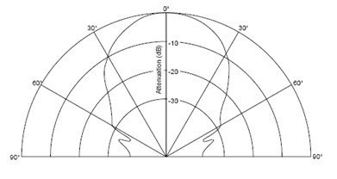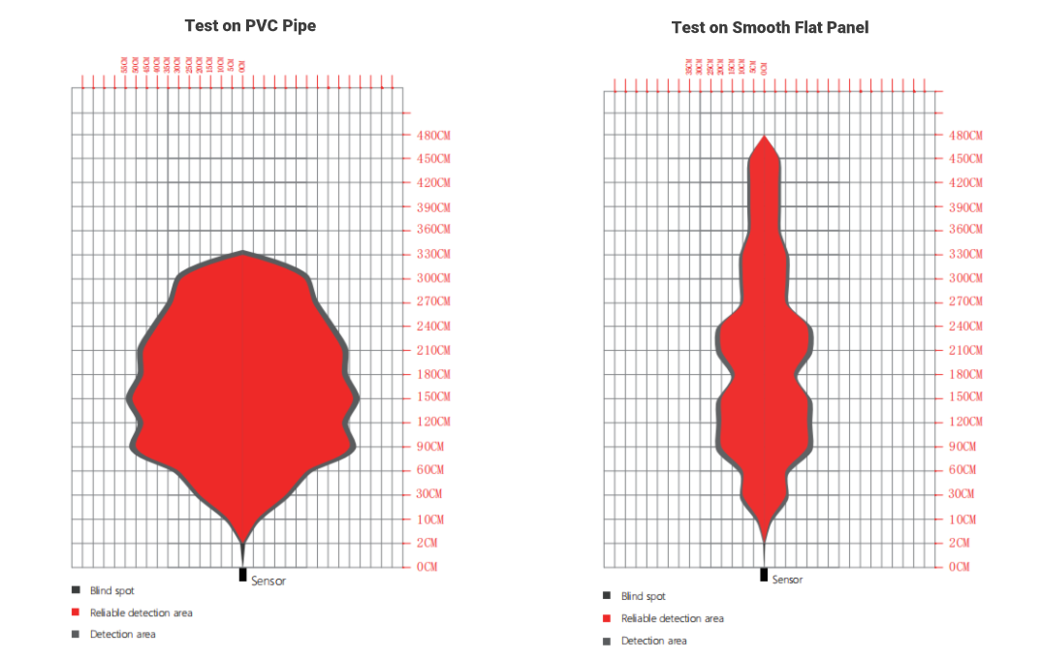We use the Ultrasonic Sensor (SEN0307) to measure the distance between the robot and the walls. This sensor utilizes analog voltage output and provides accurate distance measurements within the range of 2-500 cm with a precision of 1 cm and an accuracy of ±1%, making it highly suitable for this competition. boards with 3.3V or 5V logic level.

|  |
| --- |
| **Specification** |
| * Power Supply: 3.3~5.5V DC |
| * Operating Current: 20mA |
| * Operating Temperature: -10℃～＋70℃ |
| * Measurement Range: 2cm～500cm |
| * Resolution: 1cm |
| * Accuracy: 1% |
| * Frequency: 30Hz Max |
| * Dimension: 47mm × 22 mm/1.85× 0.87” |

**Virus-III**

We use the first Virus-III(Red sensor) to check blue line and second Virus-III(Blue sensor) to check red line to detect color values on the field. This light reflector sensor is used to measure reflected light, and in this field, we use this sensor to check the lines when the robot turns. If it encounters an orange line first, it turns right, but if it encounters a blue line first, it turns left.

GY-25

The GY-25 is a 3-axis tilt-compensated digital compass module that is commonly used in robotics and navigation projects. It typically includes a 3-axis magnetometer and a 3-axis accelerometer to provide accurate heading information even when the device is tilted. Here’s a detailed overview and how to use it with a microcontroller like an Arduino.

### **Features:**

* **3-axis Magnetometer**
* **3-axis Accelerometer**
* **Tilt Compensation**
* **Communication Interface**: I2C and Serial (UART)
* **Operating Voltage**: 3.3V to 5V

### **Pinout:**

* **VCC**: Power supply (3.3V to 5V)
* **GND**: Ground
* **SCL**: I2C Clock Line
* **SDA**: I2C Data Line
* **RX**: Serial Receive (UART)
* **TX**: Serial Transmit (UART)

We use the GY-25 sensor to determine the orientation of our robot on the field. Since the robot needs to move primarily in straight lines, we chose to use a gyro sensor to allow the robot to understand its own orientation.

Dataset: <http://mkpochtoi.ru/GY25_MANUAL_EN.pdf>

Library: <https://github.com/ElectronicCats/mpu6050>

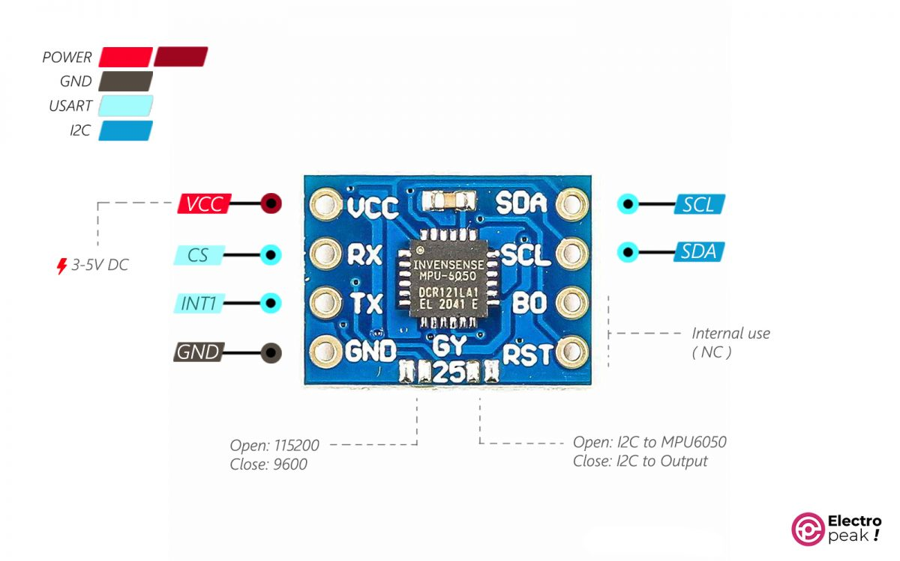

**Specifications:**

Chip: MPU-6050

Electrical Voltage: 3 - 5V

Communication Modes: Serial Communication (9600, 115200 Baud), I2C Communication

Dimensions: 15.5mm x 11.5mm

Pin Spacing: 2.54mm

Direct Data Output: Raw Data

Pitch Angle (Yaw): ± 180°

Roll Angle (Roll): ± 180°

Yaw Angle (Pitch): ± 180°

Angular Resolution: 0.01°

